CRACKING OPEN OUR WRITING



Open up your sentences and see what else you might find there!

Verbs are the Engines of Sentences
Visualize the changes each verb makes of the image and sound of the writing.

The light _________________in the window.
Streams, pours, gushes, spills, flows, surges
The boat________ in the water.
Glides, tossed, flew across, rocks, bobbed, sails, flows, skimmed, slides,

Nouns Are the Wheels of Sentences
Which are the vague nouns? How could they be more specific?
The thing broke down.

The air conditioner broke down.
She packed a lot of stuff in her bag.
I hear something on the train track.
She bought some things at the store.
It was a bird in the sky.
The flower smelled sweet.

RESEEING


T Chart
Ordinary Words Poetic Words

First words that Transform your
come to your descriptions into
mind on your figures of speech.
topic Use sensory details.

Asking Questions, Adding Details


Ask questions as a way to discover what’s left out and what details might be added.
- Read the writing aloud to the class.
- Audience listens carefully and jots down any questions they might want to ask the author.
- Author leaves the room for a few minutes.
- Students in class read the questions they wrote down, or think of new open-ended questions they’d like to ask the author when s/he returns. Open-ended questions are needed so that the writer will talk, not just say yes or no.
- Practice the questions with the teacher.
- Writer returns to the class.
- Students ask the author their questions and get him/her talking about her writing piece.
- The author brings a pencil or pen with her/him so if he/she decides there is something she wants to add to her story, she can marks it on her paper.
- The author can share with the class what new information she’ll add to her piece, or any other revisions she’ll make as a result of their questions.
- Class moves into small groups or sits with partners and read their pieces to each other. Partners create questions to ask the person about the piece.

THE LEAD
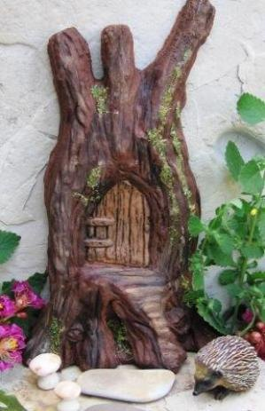
You open the front door of a house and step inside.
Immediately, you can tell if you’re comfortable or if you want to say a while. With a quick glance around, you can get a feel for the people who live in the house.

Your lead is your Front Door.



